Event report
Capacity building workshop

Concepts of Universal and Comprehensive Social Protection and International Standards

27 September 2022 | Wednesday | Brac Center Inn, Dhaka

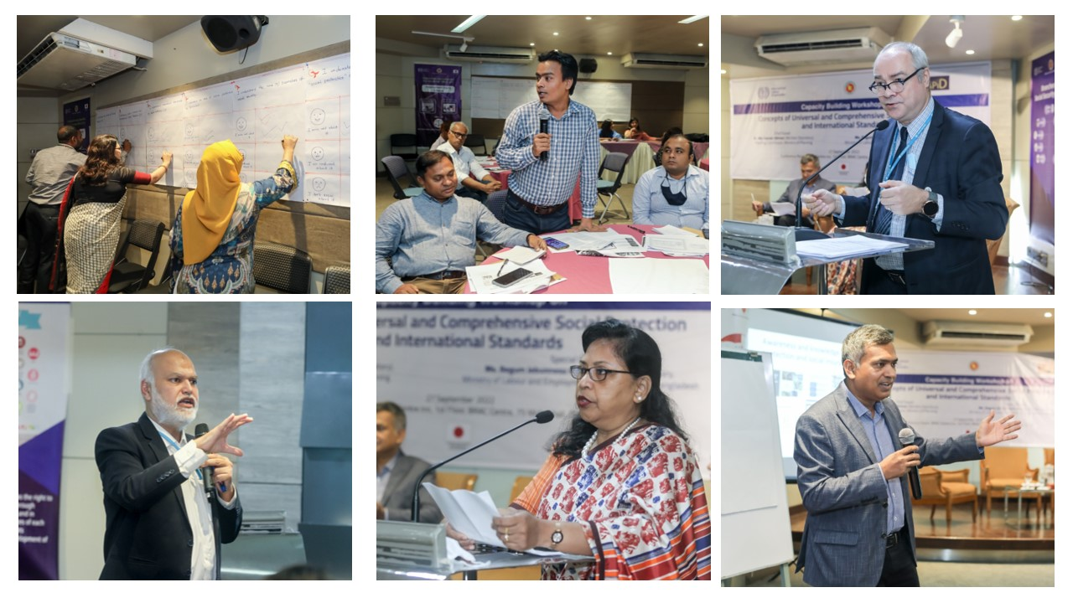

 | 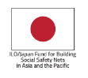

- Overview of the workshop

Universal social protection (USP) and social insurance are considered key policy instruments in national development strategies to tackle poverty and vulnerabilities, address inequality, and facilitate human development and access decent work. Such policies help develop skilled workforce and boost employability of labour market participants actively looking for jobs. These policy efforts are thus recognised as economic enablers contributing to strong, sustainable, and inclusive growth. The 2030 Agenda for Sustainable Development Goals (SDG), under Target 1.3 and Goal 1, calls for implementing nationally appropriate social protection systems and achieving a substantial coverage of the poor and the vulnerable. In recent years, many countries have made significant progress toward extending social protection and building rights-based social protection systems. Nevertheless, the onslaught of COVID-19 exposed the sheer extent of those people who are not adequately protected.

In the context of Bangladesh, the government formulated and adopted the National Social Security Strategy (NSSS) in 2015. The strategy envisages a streamlined social security system, primarily based on the widely acceptable lifecycle approach, providing support to all eligible individuals to address livelihood risks at different stages of their life e.g., childhood, working age, and old age. Nevertheless, lack of progress in implementation means vulnerabilities of the working population remain unabated. Given this, the on-going initiatives of social protection coverage expansion and the operationalisation of the National Social Insurance Scheme (NSIS)—comprising sickness, maternity, injury, and unemployment benefits for the employees — cannot be overemphasised. Meeting various social protection goals and targets has been rather slow as evident from the Midterm Progress Review of NSSS implementation. One important contributing factor in this regard is inadequate knowledge and awareness about the social protection system amongst various social partners and stakeholders including the implementing ministries/departments, employers, and employees. This problem is more prevalent when it comes to labour-related social insurance programmes. In a recent survey, carried out as part of an ILO study, a majority of participants drawn from tripartite-plus constituents self-assess their not possessing much knowledge about social security and social insurance-related issues. Lack of capacity/awareness-building initiatives have been recognised by the stakeholder representatives as the main reasons behind the social partners’ low awareness/knowledgebase.

In the above backdrop, the Ministry of Labour and Employment and ILO Country Office in Bangladesh with knowledge partner, Research and Policy Integration for Development (RAPID) undertook a capacity building workshop with the overarching goal of promoting social protection and social insurance programmes in the country. The envisaged specific objectives of the workshop include, amongst others:

- To make the social partners familiar with the key concepts and terminologies associated with social protection and social insurance related issues
- To shed light on the current state of social protection globally and the position of the Bangladesh
- To raise awareness about various technical concepts and issues associated with comprehensive and universal social protection and social insurance including international Standards and global practices
- To promote understanding about the state of social protection schemes in the country and to help improve participants’ knowledge about implementation challenges and ways to overcome those
- To discuss the role of various stakeholders in taking forward the social protection agenda and contribute to social dialogue process in building consensus

- Inauguration of the workshop

Dr M Abu Eusuf, Executive Director of RAPID commenced the programme welcoming the distinguished guests and participants. After a brief round of introduction with the participants, Mr Tuomo Poutiainen, Director, ILO Country Office for Bangladesh was invited to deliver the welcome remarks. Ms. Begum Jebunnesa Karim, Additional Secretary, Ministry of Labour and Employment, was present as the Special Guest. Dr Md Kawser Ahmed, Member (Secretary), Planning Commission, Ministry of Planning, graced the occasion as the Chief Guest. Summary of their respective remarks are provided below:

Mr Tuomo, Director, ILO Country Office for Bangladesh

Mr Tuomo Poutiainen, Director, ILO Country Office for Bangladesh welcomed the distinguished chief guest, special guest and participants present at the capacity building workshop. Addressing the audience, he noted that the ILO, as a specialised agency of the United Nations, has been working on the labour and employment as well as social protection issues since its inception in 1920. The ILO holds the international standards related to social protection, particularly to the Conventions on Social Security adopted in 1952 (No. 102) and Recommendations on Social Protection in 2012 (No. 202).

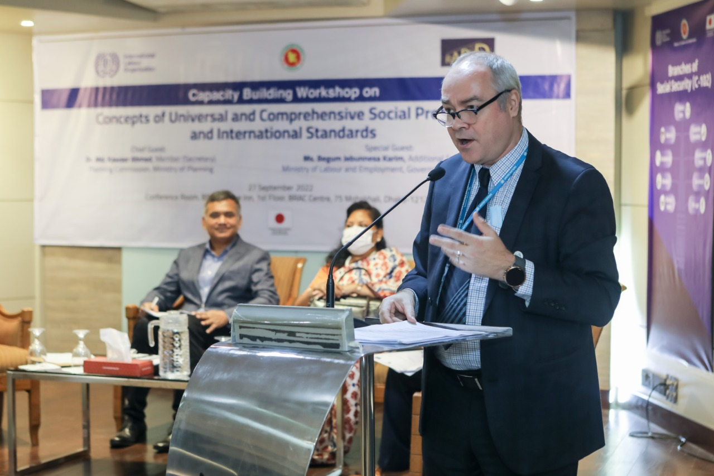

Mr Tuomo also highlighted the need for social protection for the working age population explaining their vulnerabilities to any shock or unexpected circumstances. In fact, the COVID-19 pandemic played as an eye opener to comprehend the significance of social protection for the working age people. He also underscored the importance of the compatibility of the social protection programmes with the ILO standards (conventions and recommendations).

“The social protection programmes should be designed following the international standards. Here comes the importance of the ILO which can lend technical and advisory support to all the relevant stakeholders to make the programmes compatible with those standards.”

He urged all the relevant stakeholders for their concerted efforts to develop a comprehensive social protection framework and promote social protection programmes with the objective of increased coverage.

Ms. Begum Jebunnesa Karim, Additional Secretary, Ministry of Labour and Employment

Ms. Begum Jebunnesa Karim, Additional Secretary, Ministry of Labour and Employment, graced the event as the Special Guest. At the outset, she highlighted the importance ensuring social justice and freedom for the people. She noted that the provision of social protection is embedded in the Article 15(d) of country’s constitution and social protection has been a priority area for the present government.

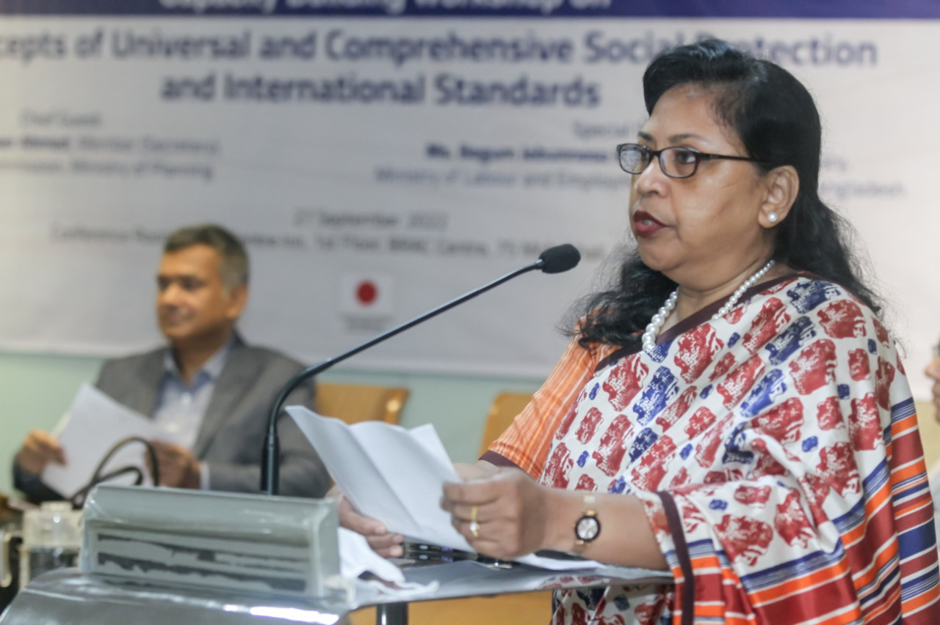

She acknowledged that the right to social protection is a human right which is one of four pillars of the ILO Decent Work Programme. Ensuring access to social protection is one of the effective measures to address the poverty and vulnerabilities of the working age people in the society. Adequate protection measures can ensure livelihood of the working people. Also, she mentioned that social protection for working people is embedded in the Bangladesh Labour Act (BLA) in the form of accident, sickness, and maternity benefits. At this point, she informed that the recently introduced central labour welfare fund for 100 per cent export-oriented industries is currently covering RMG sector workers. Workers from both the formal and informal sectors can benefit from this fund. Moreover, the workers and their families can get financial support from the from the central fund in the cases of deaths due to workplace accidents, permanent disability, treatment for acute diseases, maternity, and stipend for education of workers’ children.

She informed that the Ministry of Labour and Employment (MoLE) envisions to introduce the unemployment, accident, sickness, and maternity insurance schemes following the NSSS National Action Plan. She pointed out the recent development on employment injury scheme (EIS). The MoLE with the technical assistance from the ILO and budget support from the development partners has launched the piloting of the EIS in the RMG industry on 21 June 2022. This pilot EIS will be the first social insurance scheme in the country providing improved income protection for the workers in the event of work-related permanent disability and deaths of workers as well as other contingencies.

However, there are challenges in designing and implementing social protection and social insurance schemes. She recognised that introducing universal social protection in the developing countries like Bangladesh with huge population, unemployment, underemployment, and informal employment is not an easy task. Moreover, covering such high informal sector workers under the umbrella of social protection is extremely challenging. To give an example, she highlighted the experiences of group insurance for the construction sector workers and motor mechanics. Given the circumstances, she acknowledged the importance of knowledge and awareness regarding social protection and social insurance schemes. She appreciated the roles played by the ILO and GIZ for coming forward to promote social protection and social insurance programmes.

“Considering all the challenges, raising awareness, understanding gaps, and building capacities of social partners are very important. Hence, this workshop is expected to be a significant initiative to build the awareness and capacity of the stakeholders.”

Dr Md Kawser Ahmed, Member (Secretary), Planning Commission, Ministry of Planning

Chief Guest of the event, Dr Kawsar Ahmed (Member, General Economics Division), appreciated the initiative to organise the capacity building and awareness-raising activities to be undertaken as part of the programme. He noted that, to achieve the aspirations of higher development milestones, it is imperative to ensure economic growth is inclusive and leaves no one behind. To materialise this vision, tackling poverty and vulnerability remain a top priority of the government and enhanced social protection can significantly contribute to the process.

“While reflecting on the National Social Security Strategy 2015, inadequate knowledge and ignorance about the social protection system amongst the stakeholders including the implementing ministries, departments, agencies, employers, and employees has been acknowledged. Given the fact, conducting this type of workshop can significantly address the knowledge gaps.”

He pointed out to the findings from a recent survey of ILO which reveals that most participants who took part in the survey does not possess much knowledge about social protection and social insurance related issues. So, lack of capacity and awareness building initiatives have been recognised by the stakeholders and representatives to address this gap. He encouraged on facilitating more such workshops that can help build the capacity and also sensitise the stakeholders.

- Technical Sessions

Mr Syed Saad Hossain Gilani (Chief Technical Advisor, ILO Country Office, Bangladesh), commenced the technical session focusing on the concepts of Universal Social Protection and ILO International Standards

He highlighted the fact that different relevant stakeholders viewed social protection as complex issue and thereby their lower participation in designing, targeting, and advancing social protection programmes. As social protection is one of the core working areas of the ILO, the main objective of this session was to present the different issues of social protection and their associated international standards in a simplified manner. He defined the social protection as the combination of policies and programmes to address the poverty and vulnerabilities along the life cycle (i.e., childhood, working-age, and old-age). In this case, he defined poverty as the lack of resources or lack of access to resources. People who do not have resources or do not have resources are called poor people. On the vulnerability, the people who might have no problem today, but they might face/experience shock in the coming future periods when they cannot cover. They are called vulnerable people. Three methods of social protection: (i) social security/insurance is based on solidarity/contributory mechanism (contribution from government, employers, workers and other stakeholders) - i.e., employment injury, unemployment insurance, maternity protection, old-age pension etc.; (ii) social assistance – non-contributory mechanism based on government budget allocation i.e., social pension, food assistance, access to free health, disaster relief etc.; and (iii) active labour market policies – supported by government through relevant institutions i.e., wages, job protection, skills development, livelihoods, enterprise development etc. He also mentioned the nine branches of social security to address the contingencies having financial consequences people may face during their life cycle. They are maternity, sickness, unemployment, work injury, medical care, families with children, invalidity, death of the bread earner, old age etc.

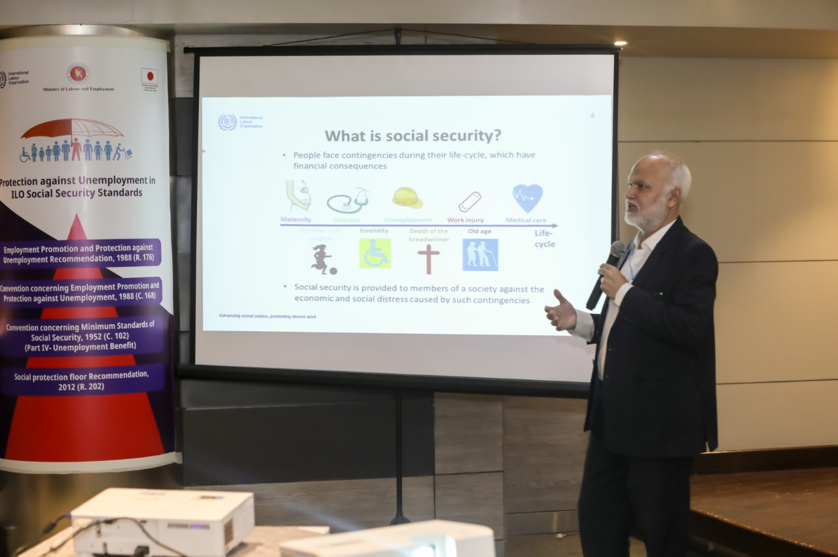

Mr. Gilani also demonstrated the basic differences between universal coverage and comprehensive social security. While universal social protection is a human right and a state responsibility, the comprehensive social security covers only the previously stated nine principal branches of social security. Under the universal social protection system, anyone who is in need of social protection can access it at any time. On the other hand, provision of benefits (in cash or in kind) are intended to ensure access to services as well as income security throughout the life cycle under the comprehensive social security. Finally, universal coverage does not mean everyone will be entitled to benefits but only those will get benefit who needs it vis-à-vis all nine branches should be available under the comprehensive social protection. However, the quantum of benefits will be defined in the context of national economy for the latter.

Mr Gilani explained the need for universal social protection. He mentioned that there is considerable rigorous of scientific evidence that well-designed and implemented social protection system can be the foundation for sustained social and economic development – for individuals, communities, nations and societies. Universal social protection can prevent and reduce poverty, promote social inclusion, and dignity of vulnerable person. Additionally, it can promote human development as well as increase productivity and employability. He also emphasised that countries with higher social protection expenditure (% of GDP) are experiencing higher labour productivity (output per worker). Mr Gilani also explained how such scheme provide protection to individuals and families against the losses due to shocks (pandemics, natural disasters, or economic downturns).

Thereafter, he focused on the international standards of social protection. He stated that the first ever instrument was the declaration of Philadelphia in 1944 (Labour is not a commodity) followed by UN Declaration of Human Rights in 1948 (everyone, as a member of society, has the right to social security – Article 22), Social Security (Minimum Standards) (No. 102) in 1952, Other Social Security Conventions in 1960, Social Protection Floors Recommendation (No. 202), and finally, Sustainable Development Goals (Target 1.3 – implement nationally appropriate social protection systems and measures for all, including floors and by 2030 achieve substantial coverage of the poor and the vulnerable) in 2015. Amongst, all these, the social security (Minimum Standards) (No. 102) is the most comprehensive one due to its robustness, universalism, and sustainability. It explains mixed system, good governance, social dialogue, state of overall responsibility, regular review, and sustainable financing. Moreover, this convention covers all the nine branches of social security. However, there are other designated conventions for every contingencies – maternity (C 183), sickness (C 130), unemployment (C 168), work injury (C 121), medical care (C 130), families with children (C 183), invalidity (C 128), Death of the breadwinner (C 128), and old age (C 128).

Explaining the need for following international standards, Mr Gilani noted that ILO is the only organisation which look at the progress on social protection in the world. If it sees the social protection programmes are not aligned with its standards, then it says that those programmes do not exist anymore. Like BD some forms of work injury – one time compensation. However, it does not go with ILO standards =, therefore, it does not recognise it as social protection programme. All the social protection programmes should be fully in line with the ILO standards, otherwise they will not be counted as social protection.

Coming to the issue of social protection floors, he informed about current development that took place and a new discussion that surfaced in the context of social protection in 2012. Based on that development and discussion, the ILO came up with the Social Protection Floors Recommendation, 2012 (No. 202) which constitutes of four guarantees:

- All residents have access to essential health care, including maternity care
- All children enjoy basic income security, providing access to nutrition, education, care, and any other necessary goods and services
- All persons in active age who cannot earn sufficient income, enjoy basic income security, particularly in cases of sickness, unemployment, maternity, and disability.
- All older persons have basic income security

The stated four guarantees are required to design and guarantee certain minimum standards for any social protection programme. Social safety nets are targeted approaches based on exclusionary mechanisms whereas social protection floor is based on the concept of universality – everyone will be covered (those who will need it). All the UN agencies and other development partners who were promoting social safety nets previously, are now agreed and endorsed the social protection floors concept.

Mr Gilani elaborated on the concept of the “missing middle”. Unfortunately, most of the social protection programmes are designed to target the poverty/poor people rather than vulnerability. However, there are only a few percentages of people are the beneficiary of these programmes. Therefore, a large share of population (self-employed, informal sector workers, or people who are not in any form of employment) are excluded from social protection. These people should be included in the social protection to address their vulnerabilities. Therefore, the social protection programmes should be based on the concept of leaving no one behind. Currently, both the inclusion and exclusion errors are there in the social protection programmes.

He stated that there should be no targeted social protection programmes. He finally appreciated the government efforts of bringing in the social protection programmes based on universality like employment injury insurance scheme. He also welcomed the government’s endorsement of universal schemes vis-à-vis targeted schemes.

Dr M A Razzaque (Chairman, RAPID) conducted an interactive session on "awareness and knowledge gaps in social protection and social insurance issues”. Dr Razzaque noted that, despite registering remarkable socio-economic progress, Bangladesh is facing major labour market challenges which include low labour force participation (which is particularly low for women); overwhelming dependence on the informal sector for employment, very high and persistent unemployment among youth; and virtually non-existent unemployment protection measures for the working age population. In the awake of the COVID-19, the vulnerabilities of the working people have been exposed very clearly. Therefore, the issue of social protection for these people has become more prominent than ever. However, even before the pandemic, the NSSS 2015 called for establishing National Social Insurance Scheme (NSIS) to provide support for the working age population. There are four components of NSIS – maternity, unemployment, injury, and sickness. The NSIS will be based on the joint contributions from employers and employees. Initially, it will be targeted to the formal sector workers and gradually extended to the informal sector workers.

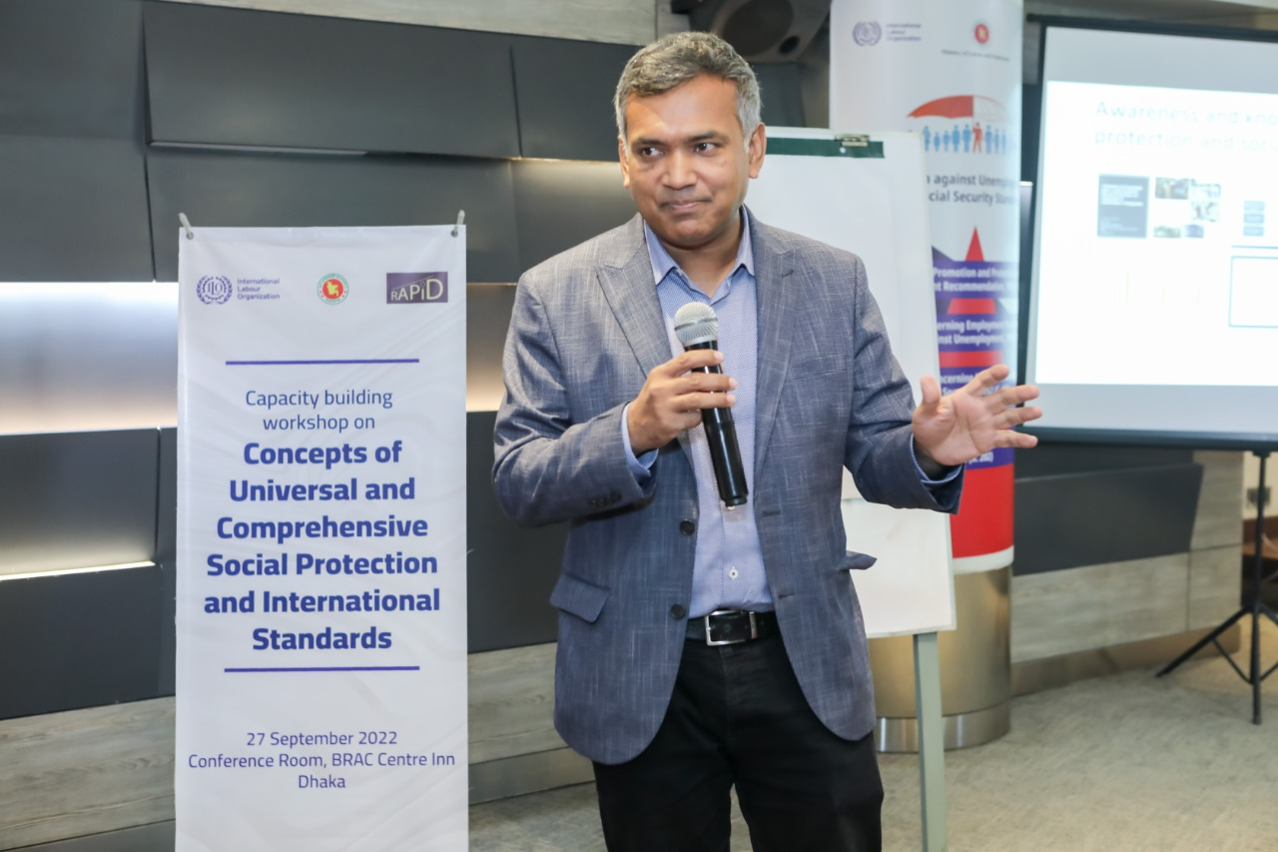

He highlighted the fact that the progress on rolling out NSIS has been extremely limited as evident from the initial implementation plan of the NSIS (i.e., NSIS was supposed to be rolled out nationwide by January 2021). Therefore, special emphasis is placed on in the revised action plan. He pointed out that lack of knowledge and awareness about the key concepts of social protection and social insurance issues is one reason for slow implementation progress as evident in the mid-term review of the NSSS implementation. When it comes to labour-related social protection programmes, lack of awareness is more acute.

Dr Razzaque shared the findings from a recent assessment. The study comprises two parts: (i) in-depth desk review (usage of major concepts and terminologies in the key policy documents) and (ii) current state of knowledge and awareness among the social partners through perception survey of key informant interviewees. Findings from the desk review suggest that there has been extremely limited usage of the relevant concepts and terminologies pertaining to social protection and social insurance in the major policy documents like the NSSS, NSSS National Action Plans, (draft) NSIS document, the 8th Five Year Plan, Bangladesh National Jobs Strategy, and National Skills Development Policy. Some important concepts and/or terminologies like active labour market policies, risk-pooling, employment promotion measures, counselling and placement services, ILO conventions and recommendations, public employment services, job searching and matching services, job centres, skills/skilling/up-skilling/skill development etc. are non-existent in those documents. Analysis of the newspaper headlines also suggests that there has been only a limited use of social protection and social insurance related issues in the headlines of major and widely circulated newspapers.

Dr Razzaque highlighted the major findings from the perception survey. Representatives from five different groups participated in the survey. They are government officials, workers, employers, analysts/experts from think tanks/development partners, and journalists. Amongst the surveyed government officials, only 30 per cent have good understanding of the concepts of lifecycle-based social security strategy. With regards to the ILO social security standards (conventions and recommendations), most of the respondents are not aware of these issues. Absence of digital contents and lack of training courses are identified as the major reason behind such low level of knowledge and awareness. The employers possess much higher understanding on the relevant issues in contrast to the workers. More than 50 per cent of the representatives of the analysts and think-tank researchers have basic to good understanding of the underlying concepts and terminologies. However, amongst the journalists, the understanding is very low. The respondents from every group opined that their peers working in the same areas possess even lower knowledge and awareness than they do.

Given these circumstances, Dr Razzaque underscored the need for sustained interventions to bridge the knowledge and awareness gaps in social protection and social insurance issues. Some of his suggestions include mass awareness building initiatives, incorporating adequate representation of relevant terminologies and their explanations in policy documents, delivering dedicated training programmes targeting the specific stakeholders, preparing appropriate and effective advocacy materials with wider accessibility, and promoting social security literacy.

Ms Noushin shah (National Project Coordinator, ILO Country Office, Bangladesh) conducted a session on the State of Social Protection in Bangladesh: Key Trends and Data Analysis.

Drawing from the World Social Protection Report 2020–22, this session focused on some key evidence on different issues of social protection from the global perspectives. Ms. Shah also highlighted the data for Bangladesh and made a cross-country comparison across a range of issues. Ms. Shah shed light on the dynamism of the development of social protection programmes anchored in national legislation from pre-1990 to 2020. For instance, prior to 1990, less than 10% of the countries had employment injury scheme. However, at present, more than 95% of the countries have employment injury scheme in place. Countries that considered higher public social protection expenditure as investment tend to realise higher economic development. Bangladesh’s spending in social protection is less than 5% of GDP which is lower than the average of the Asia and the Pacific countries (7.5%). She suggested to increase the expenditure to 12 to 13% of GDP to stimulate the economic development.

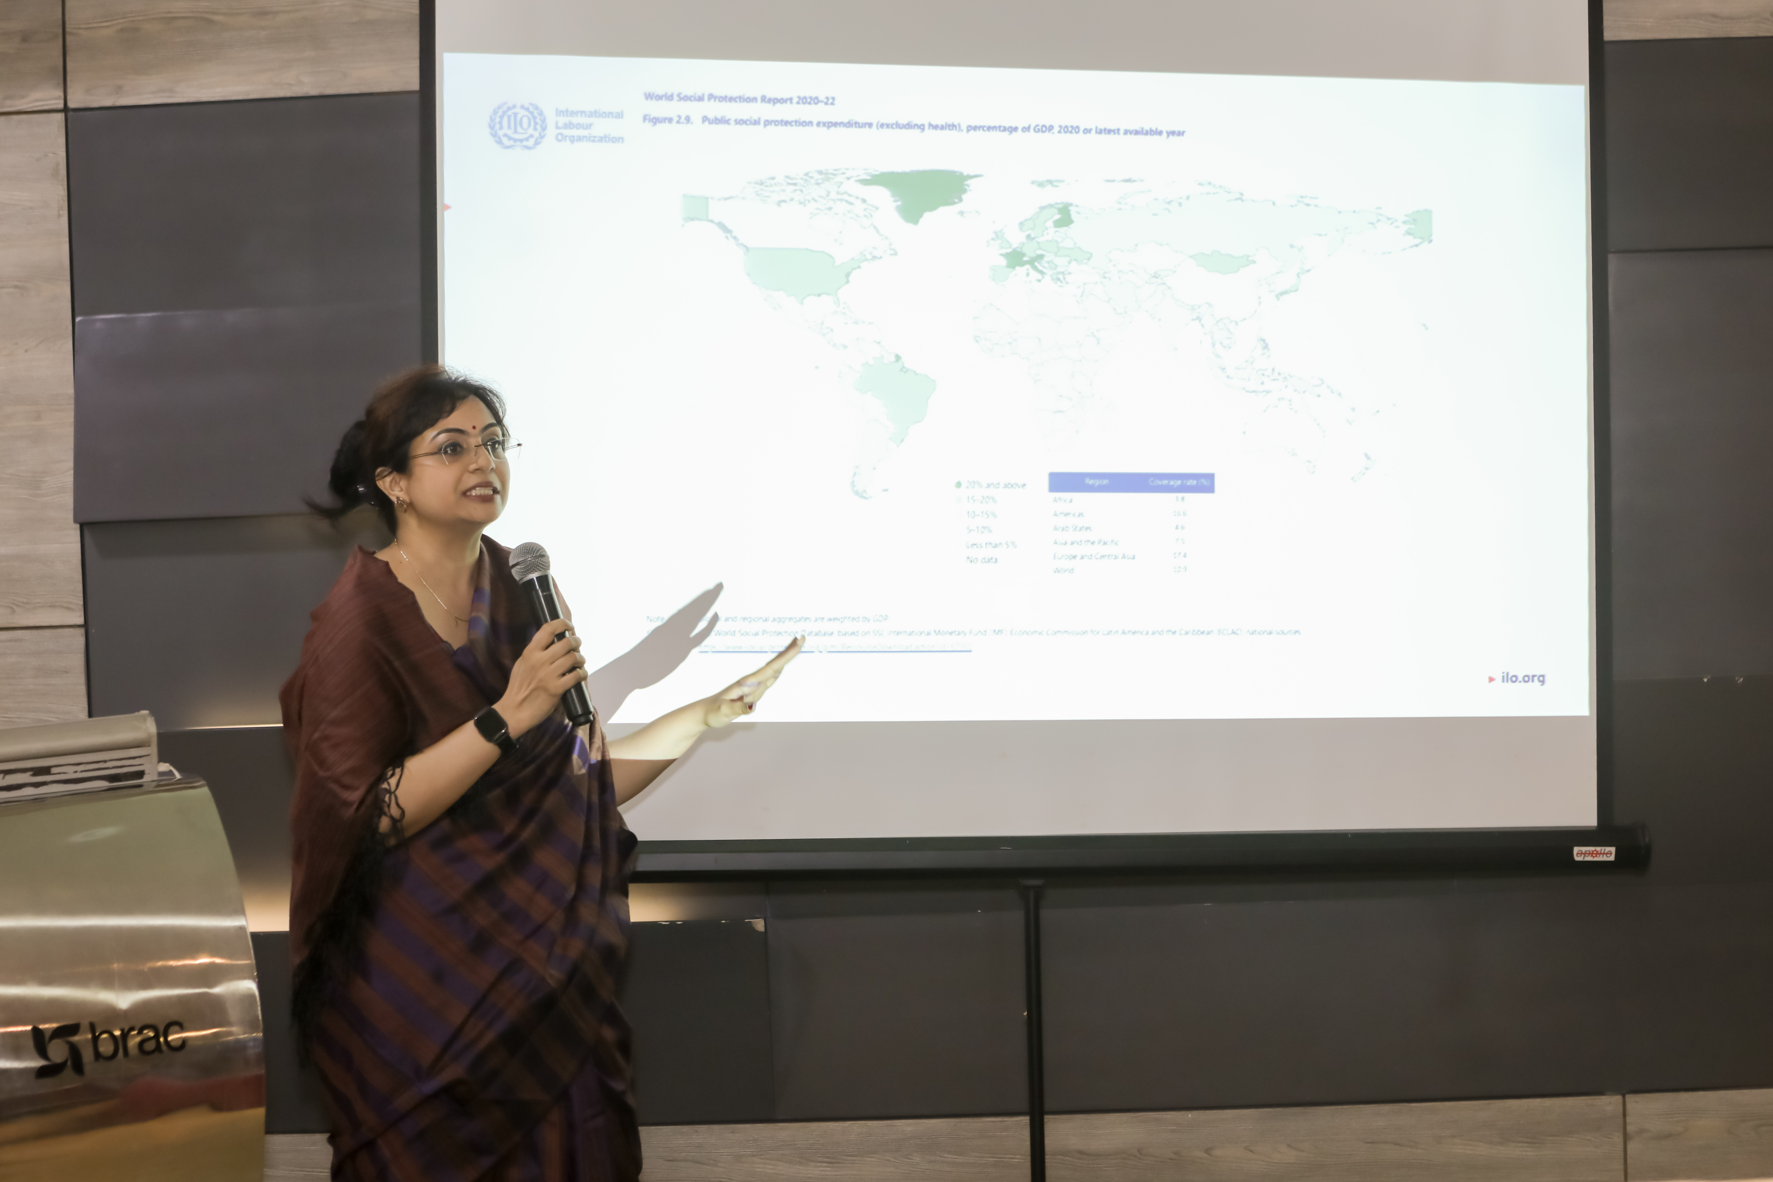

She highlighted how different branches of social security are anchored in national law and what is the mechanism of these schemes (contributory, non-contributory, voluntary schemes, employers’ liability). She noted that the ILO promotes maternity benefits based on the contributory mechanism. In the context of Bangladesh, maternity benefits are provided based on the employers’ liability provision. Under the employers’ liability mechanism, there might be a discrimination against the women in their workplaces in terms of paying benefits, ensuring jobs upon returning from leave etc. Given this context, maternity benefits should be based on the social insurance principle. On the question of maternity protection coverage, less than 20% of the pregnant women giving birth are covered in Bangladesh which is far lower than the Asia and the Pacific as well as world average of 45.9% and 44.9% respectively. One potential reason for such low coverage could be the larger share the informal sector (85%) where extending coverage is extremely difficult. Difficulties in ensuring the affiliation of those working in the informal sector in these schemes and lack of knowledge and awareness among women are some other contributing factors to the low coverage. When there is employers’ liability mechanism in place, the employers might be unwilling to provide the benefits as well. Therefore, the ILO recommends providing maternity benefits through the social insurance mechanism. The case for sickness benefits is same as the maternity benefits.

With regards to employment injury benefit scheme, only five countries (including Bangladesh) provide benefits based on the lump-sum mechanism. It is noted that employment injury benefit scheme has been considered as the first step towards implementing social insurance schemes in most of the countries. Coverage for the employment injury benefit scheme is low due to informal employment and absence workers’ registration system. Consequently, an eligible worker might not avail the benefits despite fulfilling the eligibility criteria. As coverage depends on the wage rate (at least 50% of wage), the benefits might not be adequate, especially for low-income workers. In case of disability benefits, the benefits are provided on monthly basis. However, the major issue with the disability benefits is that apart from paying cash benefits on a monthly basis, there should be arrangements for creating employment opportunities for the beneficiaries; otherwise, they might fall below the poverty line.

She highlighted that unemployment protection benefits are provided legally in around 100 countries. This the last branch of social insurance scheme. However, the coverage is low for unemployment protection. The underlying reasons are attributed to very high informal employment and lengthy unemployment period, especially during the economic downturns. Ms Shah informed that discussions are going on regarding the design of unemployment insurance schemes drawing lessons from the international experiences.

Ms Shah also notified the participants about the recent government imitative on pension which has already kicked off. She also said that old age protection needs to be improved which has low coverage (less than 20%). Currently, pension scheme is based on voluntary contribution. As a result, the working age population might think that it will take more time for them to be old. Therefore, they are reluctant to contribute to the scheme. therefore, there is a need for raising awareness among the social partners on these issues. Finally, she underscores the importance the scope for improvements in the sphere of social protection and social insurance schemes in order to be compatible with the ILO international standards.

- Structured discussion

The technical sessions were followed by a structured and interactive discussion with the involvement of participants. Mr Gilani facilitated the discussion and kicked off the discussion with an intriguing infographic that ask whether a short road and long road should be taken to build social protection systems. Participants from all the social partners’ group unanimously concurred that a high road should be taken that looks at the long-term welfare of the society and achieve universal social protection. Apart from the forward-looking approaches, participants belonging to different groups also expressed their perspectives on several issues.

Some of the participants underscored the need for social protection, especially when uncertain events occur. Ms. Nazma Akter, Executive Director, AWAJ Foundation, pointed out that
The need for a strong social protection system is comes to the forefront when events like Rana Plaza collapse surfaces. After that tragic incident, the design and development of Employment Injury Scheme (EIS) has progressed at a faster rate. But it should be a continuous process.
She also emphasised on the collaboration of the government in realising the long-term vision of ensuring social protection for all people, especially the working age population.

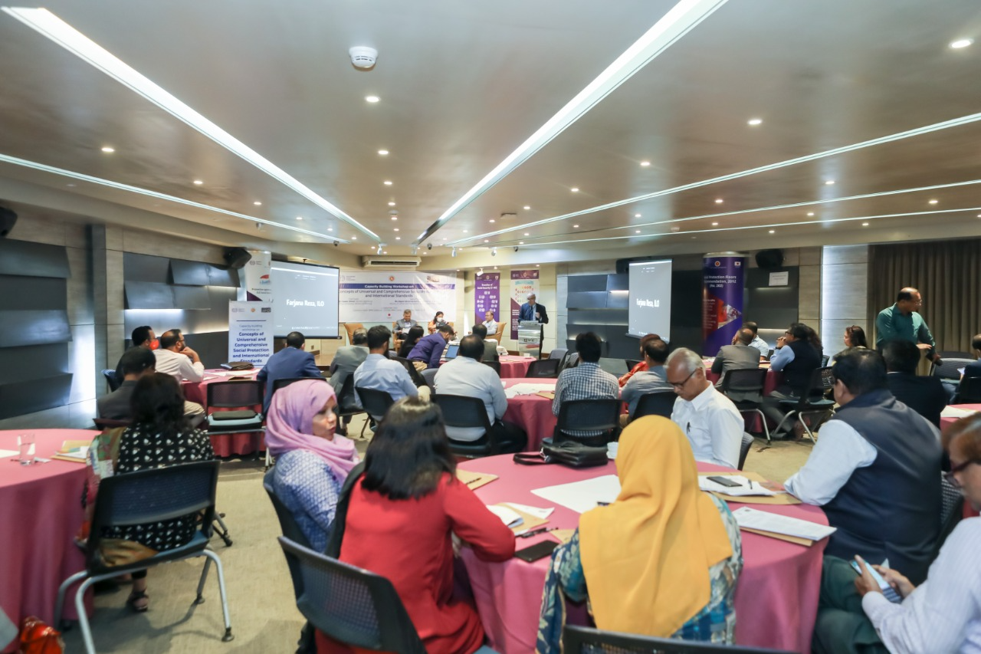

On the question of ensuring universal social protection, the participants pointed towards the workers employed in the formal sector. Informal sector workers are viewed as the most vulnerable to any unexpected shock like COVID-19. Therefore, they expressed their concern about the strategy to bring them under the social protection. Mr Farooq Ahmed (Secretary General, Bangladesh Employers’ Federation-BEF) opined that
The process of bringing everyone under the social protection coverage is a dynamic one. It is extremely difficult to expand coverage to everyone overnight. In fact, implementing the whole system within a very short time is a daunting task. So, there should be step by step strategies to implement the necessary measures.
He suggested to start off with the informal sector workers and later on expand the coverage to other sectors. He also underscored the registration process of the workers for effective monitoring, implementing, administering, and providing benefits to the eligible workers. In addition, he emphasised that contributions should come from all the relevant stakeholders. Other representatives from the employers’ group also articulated the need for social protection programmes for the workers, especially during the uncertain events. Mr Md Rafiqul Islam (Additional Secretary, BGMEA) accentuated that
Every worker should have a basic minimum protection so that s/he can protect him/her along with family whenever needed

He also focused on making documentaries on different aspects of social protection and social insurance as well as undertaking necessary steps to exhibit those documentaries to the targeted audiences. Ms. Farzana Sharmin (Joint Secretary, BKMEA) highlighted that there should be strategies to formulate and implement social protection-related awareness raising initiatives from national level to grassroot level. She added that all the relevant stakeholders need to work in a collaborative manner in making this venture a success. Participants from leather sector highlighted the need for piloting various schemes appropriate for the industrial workers.

Representatives from the workers group expressed that insurance is viewed as a complex issue amongst the workers. Ms. China Rahman, General Secretary of the Federation of Garments Workers (FWG), stated that
There are issues with the governance of workers’ support mechanism (like distribution of cash assistance during COVID-19) targeting the improvement of the workers, especially the RMG workers. Significant gaps exist between employers and workers on different fronts.
Ms Rahman articulated her concern for the eligibility criteria to avail benefits from the Central Fund. As per her statement, at least 9 months of employment is required to be entitled to get benefits from the Central Fund. However, some workers might not fulfil this criterion and thereby can be excluded from the getting benefits. However, she finally thanked the government for initiating the EIS with technical support from the ILO and financial support from the development partners like GIZ. Participants from development partners noted that, there could be an opportunity to engage lobbying group for negotiating with the employers and other stakeholders from the workers group.

Implementation of social insurance schemes, especially the unemployment insurance scheme is not all about providing benefits to potential beneficiaries. There should be arrangement for promoting active labour market policies (i.e., skills development programmes, job searching and matching services, counselling and placement services etc.) as well so that the workers can quickly get back to decent employment. However, such arrangements are virtually non-existent in the context of Bangladesh. In this regard, Mr Sharif Md Forhad Hossain (Deputy Secretary, Ministry of Labour and Employment-MoLE) noted that

The MoLE is going to establish a separate department called ‘The Department of Employment’ which will incorporate all relevant the issues pertaining to the social insurance issues including the unemployment insurance scheme.

Mr Hossain underscored the importance of social protection for the workers. Furthermore, he said that there is a need for organising such awareness raising and capacity building initiatives regularly to retain knowledge among the stakeholders.

- Major recommendations arising from the workshop

The technical sessions and discussions provided some important insights and ways forward to address the current knowledge gaps and low awareness levels among the social partners. Few recommendations are highlighted below:

- There is a need for sustained interventions to address the knowledge gaps, raise awareness amongst the relevant stakeholders, and build adequate capacity within the implementing agencies.
- The relevant concepts and/or terminologies needs to be incorporated in the major policy documents both at the conceptual level and implementation level.
- There should be arrangement for conducting trainings/capacity building workshops targeting specific group according to their needs with a view to raising knowledge and awareness.
- Based on the current state of knowledge, policies should be undertaken to prepare appropriate advocacy materials like videos, infographics, etc.
- Effective strategies should be in place to promote social security literacy. Integrating a course on social protection with the existing curricula can be a potential way forward.
- Informal sector workers need to be taken under the coverage of the social protection as well as social insurance schemes as they are the most vulnerable group to any shock.
- Understanding about the core issues of social protection and social insurance related issues should be given priority to address the prevailing misconceptions and negative connotations.
- Strengthening coordination among the ministries and implementing agencies can be an effective policy option to foster the implementation process of social security programmes.
- Special emphasis should be placed on the sustainability of the training programmes, that is retaining the knowledge derived from the training programmes.
- Policies should be designed to enhance an overall understanding of universal social protection among the tripartite-plus stakeholders.

The discussion session marked the end of the workshop. Participants filled in a pre-and post-workshop survey ad appreciated the initiative of the capacity building workshop organised by the MoLE and ILO with support from the knowledge partner – Research and Policy Integration for Development (RAPID). Moreover, the participants acknowledged that they have gained much knowledge about social protection and social insurance issues and they expect more such events in the future to build on the current knowledge base.

Annex

Annex 1: Agenda of the capacity building workshop

Annex 2: List of participants (Not according to seniority or hierarchy)

